**A. KPI:**

1. Total Revenue:

select round(sum(total_price),2) as Total_Revenue

from pizza_sales_db;



2. Average Order Value:

select round(sum(total_price) /count(distinct(order_id)),2) as Average_Order_value

from pizza_sales_db;



3. Total Pizza Sold:

select sum(quantity) as Total_Pizza_Sold

from pizza_sales_db;



4. Total Orders:

select count(distinct(order_id)) as Total_Order

from pizza_sales_db;



5. Average Pizza Per Orders:

select round (sum(quantity)/count(distinct(order_id)), 2) as Average_Pizza_per_orders

from pizza_sales_db;



**B. CHARTS:**

**1. Daily Trends for Total Orders:**

Select date_format(order_date,'%W') as order_day,

Count (distinct order_id) as Total_Orders

from pizza_sales_db

group by date_format (order_date, '%W');

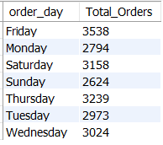

**2. Monthly Trends for Total Orders:**

SELECT DATE_FORMAT (order_date, '%M') AS Month name,

COUNT (DISTINCT order_id) AS Total_orders

FROM pizza_sales_db

GROUP BY DATE_FORMAT (order_date, '%M');

order by Total_orders Desc;

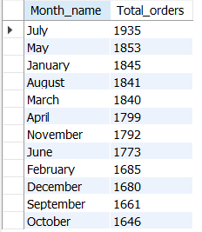

**3. Percentage of sales by Pizza Category:**

select pizza_category,

round(sum(total_price) /

(select sum(total_price) from pizza_sales_db) * 100,2) as total_sales_percentage

from pizza_sales_db

group by pizza_category;

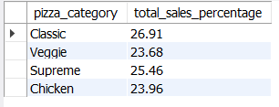

**4. Percentage of sales by Pizza Size:**

select pizza_size, round(sum(total_price) /

(select sum(total_price) from pizza_sales_db) * 100,2) as total_sales_percentage

from pizza_sales_db

group by pizza_size

order by total_sales_percentage desc;

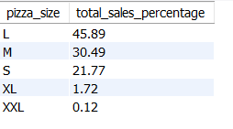

**5. Total Pizza sold by Pizza Category:**

select pizza_category as "Pizza Category", sum(quantity) as "Total Pizza Sold"

from pizza_sales_db

group by pizza_category;

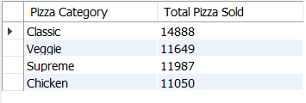

**6. Top 5 best Sellers by Revenue, Total Quantity and Total Orders:**

**SELECT pizza_name AS Pizza_Name,**

**CAST (SUM (total_price) AS DECIMAL (10, 2)) AS Total_Revenue,**

**SUM (quantity) AS Total_Quantity,**

**COUNT (distinct order_id) AS Total_Sales**

**FROM**

**pizza_sales_db**

**GROUP BY**

**pizza_name**

**ORDER BY**

**Total_Revenue DESC**

**LIMIT 5;**

**Note: There will not complete best sales in all aspects if need we can try in separate queries type. So, we consider based on Revenue.**

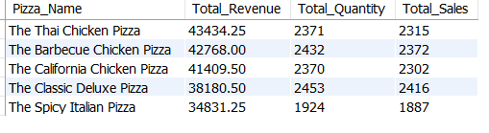

**In separate queries type,**

**SELECT pizza_name AS Pizza_Name,**

**CAST (SUM (total_price) AS DECIMAL (10, 2)) AS Total_Revenue,**

**FROM**

**pizza_sales_db**

**GROUP BY**

**pizza_name**

**ORDER BY**

**Total_Revenue DESC**

**LIMIT 5;**

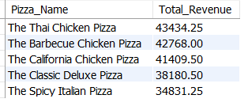

**Based on Quantity**

SELECT pizza_name AS Pizza_Name,

cast(SUM(quantity) AS DECIMAL (10, 2)) AS Total_Quantity

FROM

pizza_sales_db

GROUP BY

pizza_name

ORDER BY

Total_Quantity DESC

LIMIT 5;

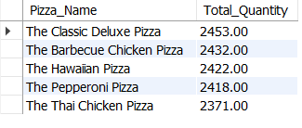

**Based on Total_sales**

SELECT pizza_name AS Pizza_Name,

count(Distinct order_id) AS Total_Sales

FROM

pizza_sales_db

GROUP BY

pizza_name

ORDER BY

Total_Sales DESC

LIMIT 5;

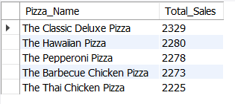

**7. Bottom 5 Sellers by Revenue, Total Quantity and Total Orders:**

**Based on Revenue**

**SELECT pizza_name AS Pizza_Name,**

**CAST (SUM (total_price) AS DECIMAL (10, 2)) AS Total_Revenue,**

**FROM**

**pizza_sales_db**

**GROUP BY**

**pizza_name**

**ORDER BY**

**Total_Revenue ASC**

**LIMIT 5;**

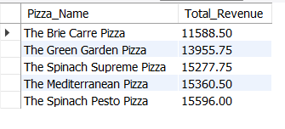

**Based on Quantity**

SELECT pizza_name AS Pizza_Name,

cast(SUM(quantity) AS DECIMAL (10, 2)) AS Total_Quantity

FROM

pizza_sales_db

GROUP BY

pizza_name

ORDER BY

Total_Quantity Asc

LIMIT 5;

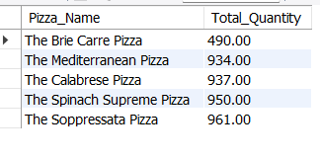

**Based on Total_sales**

SELECT pizza_name AS Pizza_Name,

count(Distinct order_id) AS Total_Sales

FROM

pizza_sales_db

GROUP BY

pizza_name

ORDER BY

Total_Sales asc

LIMIT 5;

